Are you kind-hearted, fun-loving and resilient? Do you believe in the magic of childhood and love getting down on the floor to see the world through a child's eyes?

We're looking for someone who wants more than just a job – someone who wants to make a genuine difference in the lives of our youngest children every single day. Someone who understands that strong relationships, nurture and connection are at the heart of everything we do.

At our setting, you'll be part of a small, supportive team where everyone matters and everyone is valued. We celebrate each other's successes, share plenty of laughter, and support one another through the more challenging days too. We know that early years work is incredibly rewarding, but we also know it can be tough at times. That's why we believe in having each other's backs, showing kindness, and growing stronger together.

If you're ready to bring your warmth, energy and sense of fun, while helping children build confidence, resilience and a love of learning, we'd love to hear from you.
If this sounds like you, we can't wait to meet you. ❤️
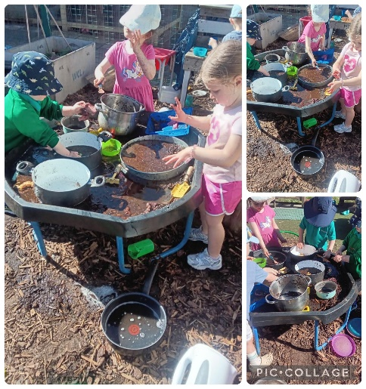
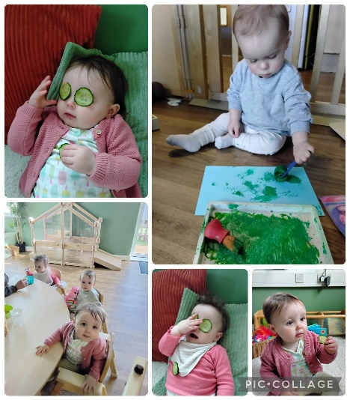
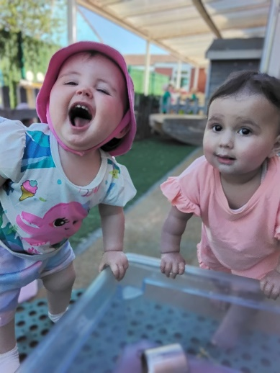
My journey at Footprints shows how combining professional skills, passion for child development and a willingness to learn can create meaningful opportunities to make a big difference in children’s lives - Kirsten

Hear from our team:
I love it here, I hope there is a job for me at the end of my apprenticeship - Katie
Kayley and Jackie – I have no intentions of ever leaving this setting and CPD is second to none!

What Skills and Qualities Are We Looking For?

🌟 Passion and Commitment
Working with young children is both incredibly rewarding and wonderfully varied. We are looking for someone who is passionate about early childhood development, dedicated to providing exceptional care, and committed to helping every child reach their full potential. You will bring enthusiasm, energy, and a genuine love for supporting children during their most important years of growth and learning.

🤝 Building Meaningful Relationships
Children flourish when they feel safe, valued, and understood. As a Childcare Practitioner, you will build warm, nurturing relationships that help children develop confidence and independence. You will enjoy spending time with children, understand their individual needs, and respond with empathy, patience, and encouragement.

💬 Strong Communication and Partnership Skills
Positive partnerships with families are at the heart of high-quality childcare. You will be approachable, friendly, and professional, building trusting relationships with parents and carers to ensure children receive consistent support both at nursery and at home. Excellent communication skills and a collaborative approach are essential.

🎨 Creativity and Inspiration
Every day is an opportunity to spark curiosity and create memorable learning experiences. We are looking for someone with a creative mindset who can plan and deliver engaging activities that inspire children to explore, discover, and learn through play. Your imagination and enthusiasm will help bring learning to life in exciting and meaningful ways.

⭐ A Positive and Proactive Attitude
You will be a team player who brings positivity, flexibility, and initiative to the role. Whether supporting children's learning, contributing new ideas, or helping colleagues, you will play an important part in creating a happy, stimulating, and inclusive environment where every child can thrive.

The purpose of the Role
As a Childcare Practitioner, you will play a vital role in creating a safe, nurturing, and inspiring environment where children can learn, grow, and thrive. You will support each child's individual development through meaningful play experiences while building strong partnerships with families and colleagues.
Key responsibilities include:
- Championing the health, safety, and well-being of every child in your care.
- Ensuring all safeguarding and child protection policies and procedures are followed at all times.
- Creating positive, respectful, and nurturing relationships that help children feel secure and valued.
- Supporting children's learning, development, and curiosity through engaging, play-based experiences.
- Acting as a Key Person for a small group of children, developing strong relationships with them and their families to support their individual needs and progress.
- Contributing to an inclusive and stimulating environment where every child is encouraged to reach their full potential.

Key Person Responsibilities
As a Childcare Practitioner, you will be a Key Person for a small group of children, helping them feel happy, settled, and secure as they transition into nursery life. You'll take the time to get to know each child as an individual, building strong, trusting relationships and working closely with their families.
By understanding each child's interests, strengths, and unique personality, you'll help create engaging experiences that support their learning, development, and progress through the Early Years Foundation Stage (EYFS).

Learning and Development
- Help create a welcoming, stimulating, and high-quality learning environment where children can explore, play, and thrive.
- Support children to enjoy rich and meaningful experiences that are appropriate to their age, stage, and individual needs.
- Contribute to the delivery of the EYFS, helping children make progress through play-based learning.
- Observe, support, and celebrate children's achievements and developmental milestones.
- Promote inclusive practice and support all children to reach their full potential.

- Work collaboratively with colleagues to deliver engaging activities and learning opportunities.
- Follow safeguarding policies and procedures to help ensure every child remains safe and well cared for.

Health and Safety
- Support the Room Leader in maintaining a safe, secure, and caring environment for children, families, colleagues, and visitors.
- Follow nursery health and safety policies and procedures at all times.
- Be familiar with emergency, security, and safeguarding procedures and know how to respond appropriately when needed.

Working Together
- Follow nursery policies, procedures, and professional standards.
- Build positive relationships with children, families, colleagues, and visitors.
- Maintain professionalism, respect, and confidentiality at all times.
- Contribute positively to the nursery team and help create a warm, supportive atmosphere where everyone feels valued.
The duties and responsibilities in this job description are not exhaustive or restrictive, changes and other duties relevant to this post may be added. This job description may be reviewed in the future.
This role offers the opportunity to make a real difference in children's lives every day while being part of a passionate and supportive team. 🌟

Our Commitment to You

Your Job Title: Level 3 Early Years Educator
Your commitment: 38 hours per week. Monday, Wednesday, Thursday and Friday, 7.45am to 6pm, permanently, all year round
Your Reward: £13.52 per hour
Where you will be: footprints@hattonhill nursery, Alwyn Avenue, Litherland, L21 9NZ

Other Benefits of Working for First Steps Enterprise Ltd

- Management team who support and believe in you
- Colleagues who coach and value you
- Children who depend on you
- Discounted childcare at our nurseries to make life easier
- Ongoing professional development, training and promotion opportunities which staff tell us is second to none
- Pension scheme* for when we grow old
- Life insurance* to protect our loved ones
- Uniform because it is a messy job

T’s & C’s
- You will need to hold a level 3 (or higher) qualification in early years as defined by the DFE list of acceptable qualifications
- The post is subject to safer recruitment checks including an enhanced DBS and two satisfactory references, one being from your last employer
- The post is subject to a 12-week probationary period
- Application forms can be found here https://firststepsenterprise.co.uk/vacancies/application-form/

